**EE7204 Computer Vision and Image Processing**

**Take-home Assignment**

EG/2018/3382

Madawalage D M K N V

[Github Repository Link](https://github.com/nivzx/ee7204-assignment.git)

Results for Q1:

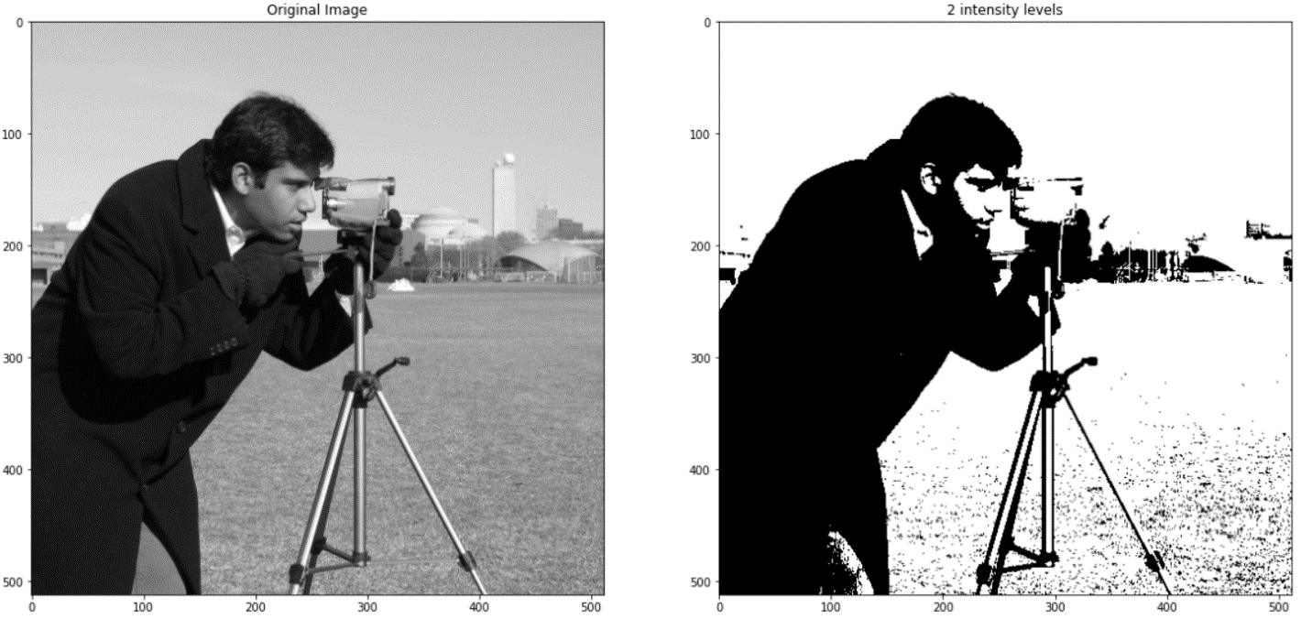

Results for Q2:

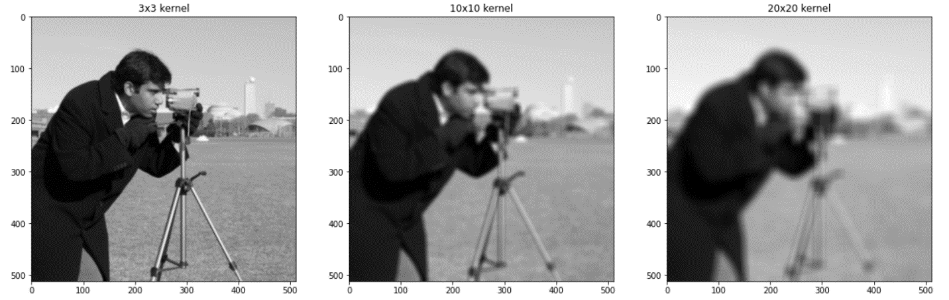

Results for Q3:

Results for Q4:

